VTCT Level 4 Certificate in Laser and Intense Pulsed Light

(IPL) Treatments (QCF)

UV30468 Client care and communication in beauty-related industries

Submitted to :-
Submitted By :-
Completion Date

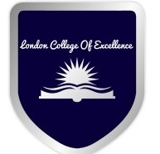

London college of excellence

Assessor comments Assessor number

Internal verifier comments IV number

Date

Outcome 1
Be able to communicate and behave in a professional manner when dealing with clients?

f. Assess the advantages and disadvantages of different types of communication used with clients ?

g. Describe how to adapt methods of communication to suit the client and their needs ?

h. Explain what is meant by the term ‘professionalism’ within beauty related industries ?

i. Explain the importance of respecting a client’s ‘personal space?

j. Describe how to use suitable consultation techniques to identify treatment objectives?

k. Explain the importance of providing clear recommendations to the client?

Outcome 2

Be able to manage client expectations

c. Evaluate client feedback d. Evaluate measures used to maintain client confidentiality?

e. Explain the importance of adapting retail sales techniques to meet client requirements?

f. Identify methods of improving own working practices ?

g. Describe how to resolve client complaints?

