N3 Assignment

**Provide Pedicure Services**

NVQ Level 2



London college of excellence limited

**Task**

Complete all questions in outcomes 4-6 & 10.

Complete questions in black in outcomes 8-9

**Attempt all questions in BLACK**

Questions in **PINK** (Outcomes 7, some of 8&9) are found in the mandatory written papers, and are optional, however, may need to be attempted at a later date

You can use any method of research that you feel appropriate, however, you must be able to prove that this is your own work.

All parts of each outcome must be answered using a standard blue or black ink, or word processed if you prefer.

**Marking**

Your tutor will mark your answers and give you written feedback, and this will be discussed with you. If you have changes to make, your tutor will agree a suitable action plan and a new deadline with you.   
You will have the opportunity to give your comments on the feedback that you have received.

**Assignment completion date**

**Assessor Signature**

**Number**

**IV Date**

**IV Signature**

**Number**

**KNOWLEDGE - OUTCOME 4**

**Understand organisational and legal requirements**

a. What are **your** responsibilities under relevant health & safety legislation and the industry code of practice for nail services?

|  |  |
| --- | --- |
| **Health & Safety Legislation** | **Industry Code of Practice for nail services** |
|  |  |

b. Why is it important not to discriminate against clients with illnesses & disabilities?

c. Why is it important to have a parent or guardian present when treating minors under 16 years of age?

d. Why is it important to gain signed, informed client consent for treatments?

e i) What is the importance of keeping and storing records of clients and their services?

f. Fill in the boxes:

|  |  |
| --- | --- |
| How to avoid potential discomfort & injury to yourself | Risks of poor positioning of clients |
|  |  |

g. i) Why is it important to maintain standards of hygiene?

ii) How could you avoid cross-infection?

h. Which of the following would be an effective way of disposing and minimising ofwaste from treatments?

1. Throwing all of your waste in one big bin
2. Use minimal tools and products and use the correct method of disposal whenever possible
3. Use disposable tools and materials as much as possible to avoid needing to tidy up after treatments
4. Put your rubbish out with household rubbish to avoid paying extra

i. Why is it important to complete treatments within a commercially viable time?

j. i) Investigate in your salon pricing structure for the following:

|  |  |
| --- | --- |
| Treatment | Price |
| Mini pedicure |  |
| Standard pedicure |  |
| Luxury pedicure |  |

ii) Investigate in your salon recommended times for the following:

|  |  |
| --- | --- |
| Treatment | Time |
| Mini pedicure |  |
| Standard pedicure |  |
| Luxury pedicure |  |

**KNOWLEDGE – OUTCOME 5**

**How to work safely and effectively when providing manicure servcies**

a. i) What type of personal protective equipment should be available and used by yourself for pedicure treatments?

1. Safety Glasses
2. An apron
3. powder free nitrile or powder free vinyl gloves
4. All of the above

ii) Why is it important to use personal protective equipment?

b i) What is contact dermatitis?

ii) How can you avoid developing it when carrying out nail services?

c. Complete the following stating how you would prepare and use the tools and materials for the pedicure service.

|  |  |
| --- | --- |
| Prepare equipment and materials for a pedicure | Use equipment and materials for a pedicure |
|  |  |

d. Illustrate below if the following are methods of disinfecting or sterilising equipment.

|  |  |
| --- | --- |
| Method | Disinfecting / Sterilising |
| Autoclave |  |
| Barbicide |  |
| UV Cabinet |  |

e. How do you effectively disinfect the feet and what is the reason for this?

|  |  |  |
| --- | --- | --- |
| Action | Importance/reasons for doing so | Methods of effective disinfection of feet |
| Disinfecting Feet |  |  |

f. State the requirements for feet treatments:

|  |  |  |
| --- | --- | --- |
| Environmental condition | Requirements | Importance |
| Lighting |  |  |
| Heating |  |  |
| Ventilation |  |  |
| General comfort |  |  |

g. How can you effectively and safely position equipment and materials for pedicure services?

h. i) How should the work area be left after you have completed the treatment?

ii) Why is this important?

**KNOWLEDGE – OUTCOME 6**

**Understand how to perform client consultation**

a. How would you use effective consultation techniques when communicating with the following?

|  |  |
| --- | --- |
| **CLIENT** | **CONSULTATION TECHNIQUES** |
| Clients from different cultural & religious backgrounds |  |
| Clients at different ages |  |
| Clients with disabilities |  |
| Clients of different gender |  |

b How would you give effective advice and recommendations to clients?

c. What are the questioning and listening skills you need in order to find out information?

|  |  |
| --- | --- |
| QUESTIONING SKILLS | LISTENING SKILLS |
|  |  |

d. Explain how you would conduct a nail and skin analysis?

e. State the importance of questioning clients to establish contra-indications to pedicure services.

f. Why is it important to record client responses to questioning?

g. What is the legal significance of client questioning, and of recording the client’s responses?

|  |  |
| --- | --- |
| Client questioning |  |
| Recording the client’s response |  |

h. Why is it important to encourage and allow time for clients to ask questions?

**i. Why is it important and what is the reason you do not name a specific contra- indication when referring clients to seek medical advice?**

j. Explain how you would prepare service plans.

**KNOWLEDGE – OUTCOME 7**

**Understand contra-indications and contra-actions that affect or restrict pedicure servcies**

1. **Complete the table below with conditions and disorders that may contra-indicate the services and why**

|  |  |
| --- | --- |
| **Contra-indications** | **Reason** |
| Fungal infections to the skin and nails |  |
| Bacterial infections to the skin and nails |  |
| Viral infections to the skin and nails |  |
| Parasitic infections to the skin and nails |  |
| Severe nail separation |  |
| Severe eczema, psoriasis and dermatitis |  |
| Infected ingrown toe nails |  |

1. **Complete the table below with conditions and disorders that may restrict the services and why**

|  |  |
| --- | --- |
| **Restrictive contra-indications** | **Reason** |
| Bunions |  |
| Corns |  |
| Callouses |  |
| Damaged nails |  |
| Varicose veins |  |

1. **List possible contra-actions which may occur during or after the pedicure service**

**KNOWLEDGE – OUTCOME 8**

**Understand the anatomy and physiology the relates to pedicure services**

**a. Label the bones of the legs and feet**

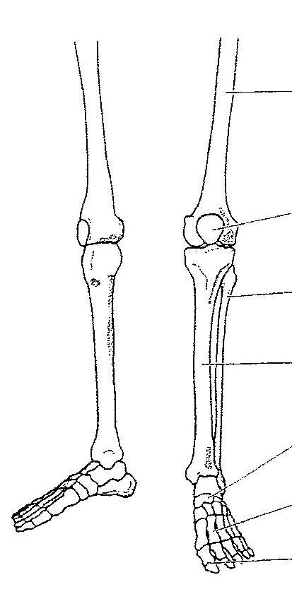

**b. i ) Label the diagram with the muscles of the lower leg and foot**

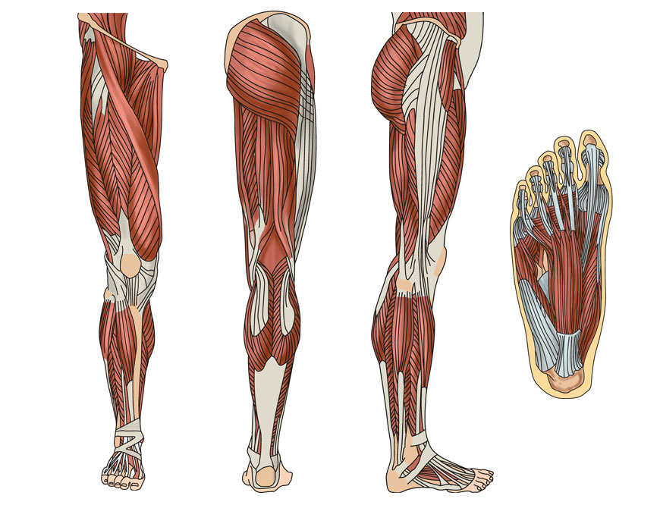

1. **Describe the function of the muscles of the lower leg:**

|  |  |
| --- | --- |
| **MUSCLE** | **FUNCTION** |
| Tibialis anterior |  |
| Extensor digitorum longus |  |
| Gastrocnemius |  |
| Soleus |  |
| Peroneus longus |  |

1. **Label the blood circulation to the leg and foot**

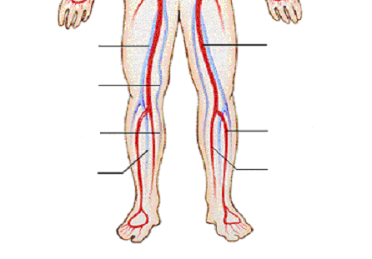

**d. Label the diagram (nail plate, nail bed, matrix, cuticle, lunula, hyponychium, eponychium, nail wall, free edge, the lateral nail fold)**

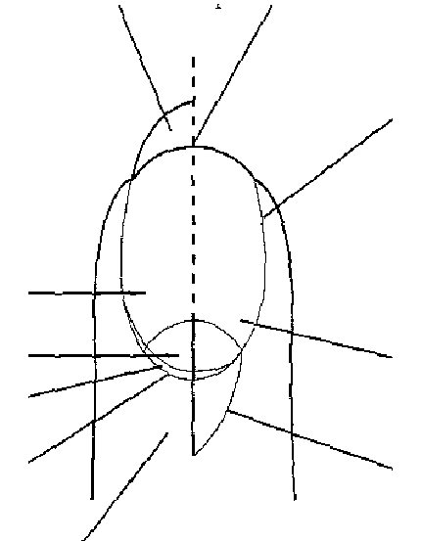

1. **Give details of how the following affect the process of nail growth:**

|  |  |
| --- | --- |
| **Nail formation** |  |
| **Growth rate** |  |
| **Factors affecting growth** |  |
| **Effects of damage on growth** |  |
| **Nail thickness** |  |

**f. i) Label the diagram of the skin**

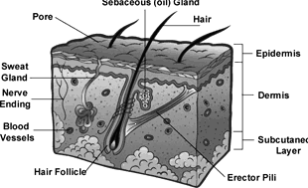

**ii) State the functions of the skin**

**g. Name the characteristics and skin types of different ethnic client groups**

|  |  |
| --- | --- |
| Ethnic group | Skin types & characteristics |
| White |  |
| Black |  |
| Asian |  |
| Mixed |  |

h. **Draw** the different natural nail shapes you are likely to come across during pedicure services

|  |  |  |
| --- | --- | --- |
| **Hook** | **Spoon** | **Fan** |
| Draw: | Draw: | Draw: |
| Describe: | Describe: | Describe: |

**KNOWLEDGE – OUTCOME 9**

**Understand Pedicure services, techniques and products**

1. **Complete the table below for how you would identify treatable nail and skin conditions**

|  |  |
| --- | --- |
| Nail/Skin condition | Characteristics |
| Discoloured nails |  |
| Dry nails |  |
| Brittle nails |  |
| Ridged nails |  |
| Thickened nails |  |
| Overgrown cuticles |  |

b. List below the different techniques used within pedicure and how to carry them out

|  |  |
| --- | --- |
| Technique | How to carry it out |
|  |  |
|  |  |
|  |  |
|  |  |

**c. How would you select and adapt pedicure services to suit individual client needs?**

**d. What are the benefits and effects of the foot and nail treatments in the range**

|  |  |  |
| --- | --- | --- |
| Range | Benefits | Effects |
| Parafin wax |  |  |
| Foot masks |  |  |
| Thermal boots |  |  |
| Exfoliators |  |  |

e & f. Complete the table below of different pedicure tools and equipment, how to use them and the effects on the nail and skin if incorrectly used.

|  |  |  |
| --- | --- | --- |
| Tools/equipment | How to use | Effects on nail if incorrectly used. |
| Dual tool/cuticle knife |  |  |
| Cuticle nippers |  |  |
| Buffer |  |  |
| Foot File |  |  |
| Heated Boots |  |  |

g. Why is it important to file the free edge straight?

h. Complete the chart describing the different types of massage movements used in a pedicure service and their benefits:

|  |  |
| --- | --- |
| Movement | Action and benefits |
| Effleurage |  |
| Petrisage |  |
| Tapotement |  |
| Vibrations |  |
| Frictions |  |

1. **What are the effects of massage techniques on the following?**

|  |  |
| --- | --- |
| STRUCTURE | EFFECTS OF MASSAGE |
| Nails |  |
| Skin |  |
| Muscle |  |
| Underlying structures |  |

**j. Complete when the following types of massage mediums should be used:**

|  |  |
| --- | --- |
| Medium | When used |
| Oil |  |
| Cream |  |
| Talc |  |

k. What is the importance of removing excess moisture, debris and product from the natural nail to prepare for required nail finish?

L. State the importance of recommending a nail finish suitable for the client.

**m. i) What are the reasons for applying base and top coat?**

**ii) What are the consequences for not applying a base and top coat**

n. Complete below the correct method of applying nail finishes for the following:

|  |  |
| --- | --- |
| Finish | Correct application |
| Dark |  |
| French |  |
| Buffed |  |

**KNOWLEDGE – OUTCOME 10**

**Understand the aftercare advice to provide to clients for pedicure services**

a. i ) What aftercare and maintenance requirements would you give your client for pedicure services?

ii). Why is it important to offer aftercare advice?

b. What advice would you give to the client with regards to products and tools they can use at home that will benefit them?

**c. List the contra-actions that could occur after nail services, and state the advice that you would give to clients**

|  |  |
| --- | --- |
| Contra-actions that may occur AFTER services | Advice given to clients |
|  |  |

d. What would be the recommended time intervals for nail services?