BT16 Epilation Assignment

Learner Name
Assignment completion date

Assessor Signature

Number

IV Date

IV Signature

Number

Task
Complete all questions in outcomes 4-6, some of 9&10.
Attempt all questions in BLACK

Questions in BLUE (Outcomes 7&8, 9e-g, l&m, and 10 a-c) are found in the mandatory written papers, and are optional, however, may need to be attempted at a later date

You can use any method of research that you feel appropriate, however, you must be able to prove that this is your own work.
All parts of each outcome must be answered using a standard blue or black ink, or word processed if you prefer.

Marking
Your tutor will mark your answers and give you written feedback, and this will be discussed with you. If you have changes to make, your tutor will agree a suitable action plan and a new deadline with you.
You will have the opportunity to give your comments on the feedback that you have received.

KNOWLEDGE AND UNDERSTANDING OUTCOME 4
Understand the organisational and legal requirements of providing electrical epilation

a) What are your responsibilities regarding this treatment for the following:

Relevant health and safety legislation
COSHH
Electricity at Work Act
Local Authority legislation

b) Why is the Disability Discrimination Act so important within the salon environment?

c) At which age is an individual classed as a minor, and how this differs nationally

d) Justify the importance of checking current insurance guidelines and age-related restrictions for electrical epilation treatment

e) Why should minors only be treated with the informed consent and presence of a parent or guardian?

f) Explain the legal significance of gaining signed, informed consent to treatment

g) Explain local authority and organisational requirements for waste disposal

h) Explain the importance of storing client records in accordance with the Data Protection Act

- Explain how to maintain client records in the salon and their importance

j) Explain your own responsibilities and reasons for maintaining personal hygiene, protection and appearance, according to accepted industry and organisational requirements
Personal hygiene
Protection
Appearance

k) List four requirements for client preparation:

l) State the commercial times for carrying out the following

Treatment | Commercial times
Upper lip epilation
Underarm epilation
Bikini line epilation
Neck epilation

m) Explain the organisation’s requirements for the following:
Aspect | Requirements
Client preparation
Treatment area
Equipment maintenance
Equipment cleaning regimes

KNOWLEDGE AND UNDERSTANDING OUTCOME 5
Understand how to work safely and effectively when providing electrical epilation treatments

- Explain how you would safely prepare the work area for electrical epilation treatments.

- Complete the environmental conditions required for this treatment:
Environmental conditions | Requirements
Lighting

Heating

Ventilation

General Comfort

- Explain the types of personal protective equipment that should be worn for electrical epilation treatments and why

- Explain the condition contact dermatitis and how to avoid developing it whilst carrying out electrical epilation treatments

- How can the therapist avoid repetitive strain injury (RSI)?

- Explain the causes and hazards of accidental exposure to clinical waste

- Explain how to disinfect hands and its importance

h)
Name three ways to avoid potential discomfort and injury to yourself? | What is the risk of poor positioning of the client?

- State 3 ways of avoiding cross infection:

- Why is it important to maintain the client’s confidentiality and privacy?

- To avoid therapist embarrassment
- So that the client cannot see the treatment being performed
- So that the client is comfortable and avoid embarrassment

- Why is it important to monitor the client’s well-being at regular intervals?

KNOWLEDGE AND UNDERSTANDING OUTCOME 6
Understand the use of client consultation for electrical epilation treatments

- Explain how to use consultation techniques to meet the needs of different client groups

- How would you give advice, and make recommendations to clients?

- How can communication and discussion with the client be effective, and why is this so important?

- Why is it important to encourage the clients to ask questions about the treatment?

- Why is it necessary to record information on a treatment plan and record card?

- Justify the importance of explaining the commitment required to maintain optimum results

- Why is it advisable to take photographs of the treatment area before and after treatment?

How should these be taken and stored to maintain client confidentiality?

- Complete the characteristics for skin and hair types and their affect on treatment:
Skin/Hair type | Characteristics | Affect on treatment
Dry
Oily
Sensitive
Dehydrated
Mature
Combination
Fine hair
Coarse hair
Curly hair

- Explain how to carry out a patch test to identify skin allergies, reactions and issues

- Justify the importance of providing clients with written aftercare instructions immediately after the test patch and reinforcing this on subsequent visits

- Explain why it is important to maintain client confidentiality

- Explain the types of alternative treatments to recommend if contraindications to electrical epilation are identified

- Justify the importance of providing information to assist the client’s understanding of the treatment

- Clarify the constraints surrounding electrical epilation treatments

o)i. What physical sensation is relevant to each epilation method?

High frequency

Direct current

Blend

ii. Explain how the pain threshold and sensitivity varies for different treatment areas

- How is skin sensitivity affected by other skincare treatments?
Glycolic peel
Micro-dermabrasion
Laser

- Why is it important to consult with the client’s record card for previous treatments?

KNOWLEDGE AND UNDERSTANDING OUTCOME 7
Understand anatomy and physiology relevant to electrical epilation.

a) Label the diagram of the skin

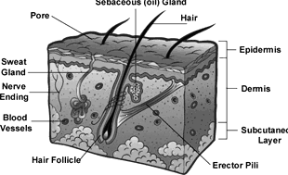

ii. State the functions of the skin

iii. List the layers of the epidermis & explain the function of each layer

Layer | Function
1.
2.
3.
4.
5.

iv. Briefly describe the function of the following:

Layer/Appendage | Function
Reticular layer
Papillary
Connective Tissues
Nerve Endings
Sweat Glands
Sebaceous Glands
Capillaries
Hair
Subcutaneous Layer

b) Explain the characteristics and typical skin types of different ethnic client groups

- Explain the principles of skin healing

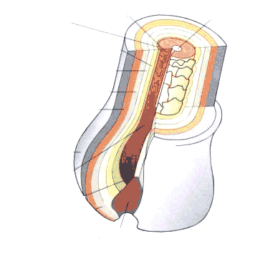
d) Label the diagrams below

Layers of the hair

Structure of the hair in its follicle
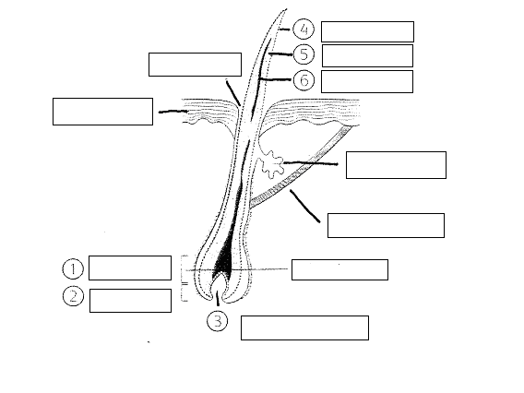
- i. Briefly describe the pattern of hair growth

ii. How does this affect present and future treatments?

f) Label the diagram below. 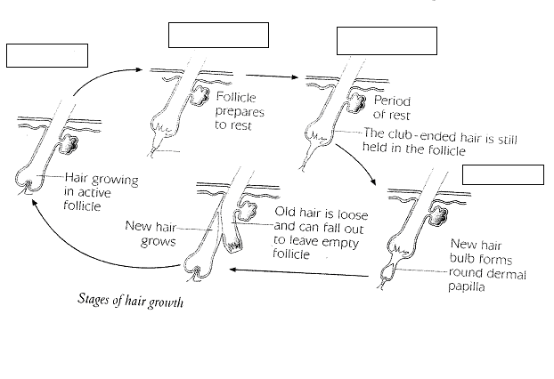
ii. What is meant by each of the following causes of hair growth?
Topical
Congenital
Systemic

iii. Briefly explain the following definitions of hair growth:

Superfluous

Hirsutism

Hypertrichosis

- Explain the following types of hair growth:
Terminal
Lanugo
Vellus

g)
Explain the structure and function of the endocrine system
Structure
Function

- How do the following malfunctions of the endocrine system affect hair growth:
Virilisation

Polycystic ovary syndrome

Cushing’s syndrome

Anorexia nervosa

- What are the principles of the blood and lymphatic system?

- How does lymph and blood interact within the circulatory system?

- How are hormones circulated via the blood stream?

KNOWLEDGE AND UNDERSTANDING OUTCOME 8
Understand the contra-indications and contra-actions of electrical epilation

a,b,c) Briefly describe each of the contra-indications and restrictive contra-indications listed below:
Condition | Description | Prevent/ medical approval/ restrict | Reason
Skin cancer in the area
Contagious skin diseases
Haemophilia
Epilepsy
Diabetes
Heart disease
Pacemakers
Moles and pigmented naevi
Pregnancy
Impetigo
Psoriasis
Eczema
Acne

- What would be the consequences of carrying out electrical epilation on a contra-indicated client?

- How would the therapist deal with the following client contra-actions if they happened during the treatment?
Palpitations

Profuse sweating

Erythema

Oedema

f) Briefly describe why you would do each of the following:

- Encourage the client to seek medical advice

- Explain to the client why treatment cannot be carried out

- Modify the treatment

- Not naming specific contra-indications when encouraging clients to seek medical advice

KNOWLEDGE AND UNDERSTANDING OUTCOME 9
Understand the use of equipment and materials in electrical epilation

- Explain the types and uses of equipment, materials and products for electrical epilation
 | Types | Use
Equipment
Materials
Products

- Complete the preparation and use the following materials and equipment:
Materials & Equipment | Preparation | Use
Epilation unit

Probe and chuck

Needles

Tweezers

- Why is it important that the therapist follows manufacturers’ instructions?

- Name four items that would be deemed unsuitable for use in epilation treatments:

- How would you decide that a product, equipment or material was unsuitable for use?

- State which method of sterilisation, disinfection and sanitising is used for each of the following:
Magnifying lamp

Tweezers

Needle

Couch

- Briefly describe the available types of needles
One piece

Two piece

Stainless steel

Gold

Insulated

ii. How does the therapist determine the size of needle required?

KNOWLEDGE AND UNDERSTANDING OUTCOME 10
Understand how electrical epilation treatments are used

- Why is it important to magnify and light the area to be treated?

- Why is it important to reassure the client during the treatment?

- Briefly describe how to work systematically and methodically with dense and scattered hair growth.

- Describe the principles, uses and benefit of galvanic and alternating currents
Current | Principles | Uses | Benefits
Galvanic
Alternating

- Describe the principles, uses and benefits of blending the galvanic and alternating currents

Current | Principles | Uses | Benefits
Blend

- Describe how to select the type and size of needle to suit the hair type, skin type and areas to be treated.

- What is the reason for stretching and manipulating the skin?

- How would the therapist correctly insert the needle into the hair follicle with regard to depth and angle?

- Name three reasons for skin sensitivity:

- Describe how to adapt electrical epilation methods to suit different skin conditions, hair types and treatment areas
Skin conditions | Hair types | Treatment areas

- How would you adapt electrical epilation methods to client’ emotional state and physical condition?

- Briefly describe how to remove hairs from the different types of hair follicle:
Single

Compound

Distorted

- What is the importance of recognising and treating unusual hair growth?

- What are the benefits and effects of post-treatment Cataphoresis?

o) How can the therapist identify the following and what are their causes:
Erythema

Oedema

- Briefly describe how to treat the follicles of red and non-pigmented hair?

- How can moisture affect the epilation treatment?

- Describe the importance of providing aftercare advice to clients relating to product use, hygiene and hair management in-between treatment.

KNOWLEDGE AND UNDERSTANDING OUTCOME 11
Understand how to provide aftercare advice following electrical epilation

- Explain the normal reactions which occur after treatment and how to resolve abnormal reactions

- Explain the lifestyle factors and changes that may be required to improve the effectiveness of the treatment

- Explain post-treatment restrictions and future treatment needs

- Explain the reasons for avoiding different post-electrical epilation activities

- Clarify beneficial and unsuitable products for the client’s home use

- Name three suitable methods for dealing with hair re-growth between treatments?

