B24 Assignment

Carry out massage using pre-blended aromatherapy oils

NVQ Level 3

**Task**

Complete all questions in outcomes 4-7, 8(p), 10(b-d),11-12.

**Attempt all questions in BLACK**

Questions in **BLUE** (Outcomes 8, 9 and 10a) are found in the mandatory written papers, and are optional, however, may need to be attempted at a later date

You can use any method of research that you feel appropriate, however, you must be able to prove that this is your own work.

All parts of each outcome must be answered using a standard blue or black ink, or word processed if you prefer.

**Marking**

Your tutor will mark your answers and give you written feedback, and this will be discussed with you. If you have changes to make, your tutor will agree a suitable action plan and a new deadline with you.   
You will have the opportunity to give your comments on the feedback that you have received.

**Assignment completion date**

**Assessor Signature**

**Number**

**IV Date**

**IV Signature**

**Number**

**Learner Name**

# Knowledge – Outcome 4

# Understand organisational and legal requirements for carrying out massage using pre-blended aromatherapy oils

1. What are your responsibilities under current health and safety legislation, standards and guidance, eg the Health & Safety at Work Act (and any other relevant legislation)?
2. What are your responsibilities under local authority licensing regulations for yourself and your premises?
3. Why is it important to not discriminate against clients with illnesses and disabilities?
4. At what age is an individual classed as a minor and how does this differ nationally?
5. Why is it important to have a parent or guardian present when treating minors under 16 years of age?
6. Why should minors not be given services without informed and signed parental or guardian consent?
7. What is the legal significance of gaining signed, informed client consent to the services?
8. What are your responsibilities, and reasons for maintaining your own personal hygiene, protection and appearance according to accepted industry and organisational requirements :

|  |  |  |
| --- | --- | --- |
| Aspect | Responsibilities | Reasons |
| Personal hygiene |  |  |
| Protection |  |  |
| Appearance |  |  |

1. Briefly describe the requirements for waste disposal according to:

|  |  |
| --- | --- |
| Manufacturers | Organisational requirements |
|  |  |

1. What is the importance of the correct storage of client records in relation to the Data Protection Act?
2. i) How would you complete the client record cards used in your salon?

ii) Why is it important to keep these records of treatments and gained client signatures?

1. How would you meet your organisation’s requirements for client preparation?
2. i) Investigate the following within your salon for massage treatments:

|  |  |
| --- | --- |
| Treatment | Service time |
| Full body massage |  |
| Back neck & shoulder massage |  |

ii) Why is it important to complete treatments within a commercially viable time?

1. How would you follow your organisations and manufacturers’ requirements for treatment area, equipment maintenance and equipment cleaning regimes?

|  |  |  |
| --- | --- | --- |
| Aspect | Organisational requirements | Manufacturers guidelines |
| Treatment area |  |  |
| Equipment maintenance |  |  |
| Equipment cleaning |  |  |

**Knowledge – Outcome 5**

Understand how to work safely and effectively carrying out massage using pre-blended aromatherapy oils

1. Explain how you would set up the work area for body massage treatments
2. i). Complete the table below for body massage treatments:

|  |  |
| --- | --- |
| **Environmental conditions** | **Requirements** |
| Lighting |  |
| Heating |  |
| General Comfort |  |
| Ventilation |  |
| Sound |  |

ii). Why is it important to have the correct environmental conditions for massage treatments?

1. i). State the importance and reasons for disinfecting your hands?

ii). How do you effectively disinfect your hands?

1. Detail below how to position yourself and the client, with individual physical characteristics in mind

|  |  |
| --- | --- |
| How to position **yourself** | How to position the **client** |
|  |  |

e. i). What is repetitive strain injury (RSI)?

ii). How is RSI caused?

iii). How can you avoid developing it when delivering massage treatments?

1. What is the importance of adopting the correct posture throughout the treatment and the impact this may have on yourself and the outcome of the treatment?

|  |  |
| --- | --- |
| Aspect | Reason |
| Correct posture |  |
| Impact on self |  |
| Impact on outcome of treatment |  |

1. Why is it important to maintain client’s modesty, privacy and comfort during the treatment?

a. To avoid therapists embarrassment

b. So that the client can not see the treatment being performed

c. So that the client is comfortable and avoid embarrassment

1. i). Why is it important to maintain standards of hygiene?

ii) Give examples of ways In which you can avoid cross-infection

1. Which of the following would be an effective way of disposing and minimising of waste from treatments?
2. Throwing all of your waste in one big bin
3. Use minimal tools and products and follow the manufacturers’ instructions for the correct method of disposal whenever possible
4. Use disposable tools and materials to avoid the need to tidy up after treatments
5. Put your rubbish out with household rubbish to avoid paying extra

# Knowledge – Outcome 6

Understand how to consult with clients

1. Give examples of effective consultation techniques when communicating with the following:

|  |  |
| --- | --- |
| Client | Consultation techniques |
| Clients from different cultural & religious backgrounds |  |
| Clients at different ages |  |
| Clients with disabilities |  |
| Clients of different gender |  |

1. Why is it important to encourage and allow time for clients to ask questions?
2. Why is it important to question clients to establish any contra-indications to head and body massage treatments?
3. What is the importance of recording client responses to questioning?
4. i) What is the legal significance of client questioning concerning contra- indications?

ii) What is the legal significance of recording the client’s responses to questioning?

1. How can you give effective advice and recommendations to clients?
2. How would you visually assess the client’s physical characteristics?
3. Briefly describe the following types of postural and skeletal conditions and how you would adapt and change the routine:

|  |  |  |
| --- | --- | --- |
| Condition | Description | Adaptation |
| Lordosis |  |  |
| Scoliosis |  |  |
| Osteoporosis |  |  |
| Spondylitis |  |  |

1. How would you recognise different skin types and conditions? Give examples
2. How would you carry out a skin sensitivity test for allergies to pre-blended oils?
3. Give examples of the kinds of reactions that can occur when using pre-blended.

ii) How would you recognise these reactions?

1. Why is it important to encourage clients with contra-indications to seek medical advice?
2. Why is it important and for what reason would you not name specific contra-indications when encouraging clients to seek medical advice?
3. Why is it important to maintain the client’s modesty privacy and comfort?

a. To avoid therapist embarrassment

b. So that the client cannot see the treatment being performed

c. So that the client is comfortable and avoid embarrassment

1. Briefly describe the relationship between lifestyle patterns and effectiveness of treatment.
2. Briefly describe how changes to the following can benefit the client:

|  |  |
| --- | --- |
| Change | Benefit |
| Healthy eating & fluid intake |  |
| Exercise habits |  |
| Smoking habits |  |
| Sleep patterns |  |
| Hobbies & Interests |  |
| Means of relaxation |  |

**Knowledge – Outcome 7**

Be able to prepare to carry out massages using pre-blended aromatherapy oils

* 1. Why is it important to give clients clear instructions on the removal of relevant clothing, accessories and general preparation for the treatment?

1. Why is it important to reassure clients during preparation for the treatment?
2. List the pre-blended aromatherapy oils you would use, and state the skin types, conditions and treatment objectives that they would be used for:

|  |  |
| --- | --- |
| Oil | Skin Type and conditions and treatment objective |
|  |  |
|  |  |
|  |  |
|  |  |
|  |  |

1. Name two areas of the body which will require cleansing in preparation for the treatment and explain how it would be done:

# Knowledge – Outcome 8

Understand anatomy and physiology related to body massage treatments

1. **i) Label the diagram of a cell**

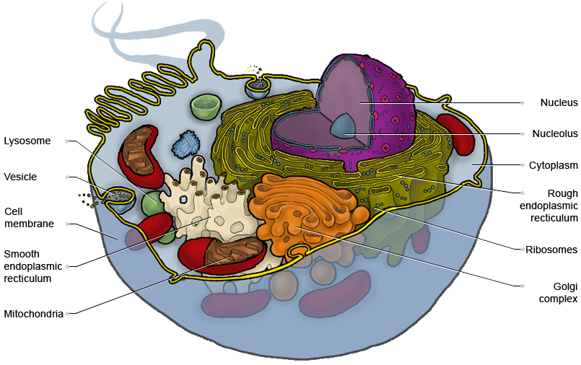

**ii) Complete the chart below**

|  |  |
| --- | --- |
| Structure | Function |
| CELL MEMBRANE |  |
| CYTOPLASM |  |
| ORGANELLES |  |
| NUCLEUS |  |
| GOLGI COMPLEX |  |
| MITOCHONDRIA |  |
| NUCLEOLUS |  |
| LYSOSOME |  |
| RIBOSOMES |  |
| ROUGH ENDOPLASMIC RECTICULUM |  |
| SMOOTH ENDOPLASMIC RECTICULUM |  |
| VESICLE |  |

**iii) Briefly describe the structure & functions of the following tissues:**

|  |  |  |
| --- | --- | --- |
| Tissue | Structure | Function |
| **Epithelial** |  |  |
| **Connective** |  |  |
| **Muscular** |  |  |
| **Nervous** |  |  |

* 1. **i). Label the diagram of voluntary muscle**

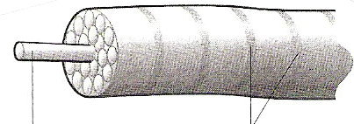

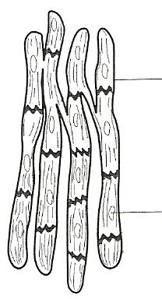**ii) Label the diagram of involuntary muscle**

**iii) Label the diagrams of the muscles in the body**

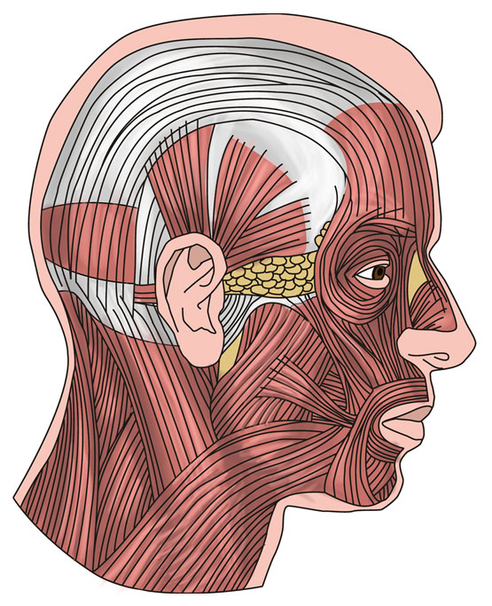

Shoulder

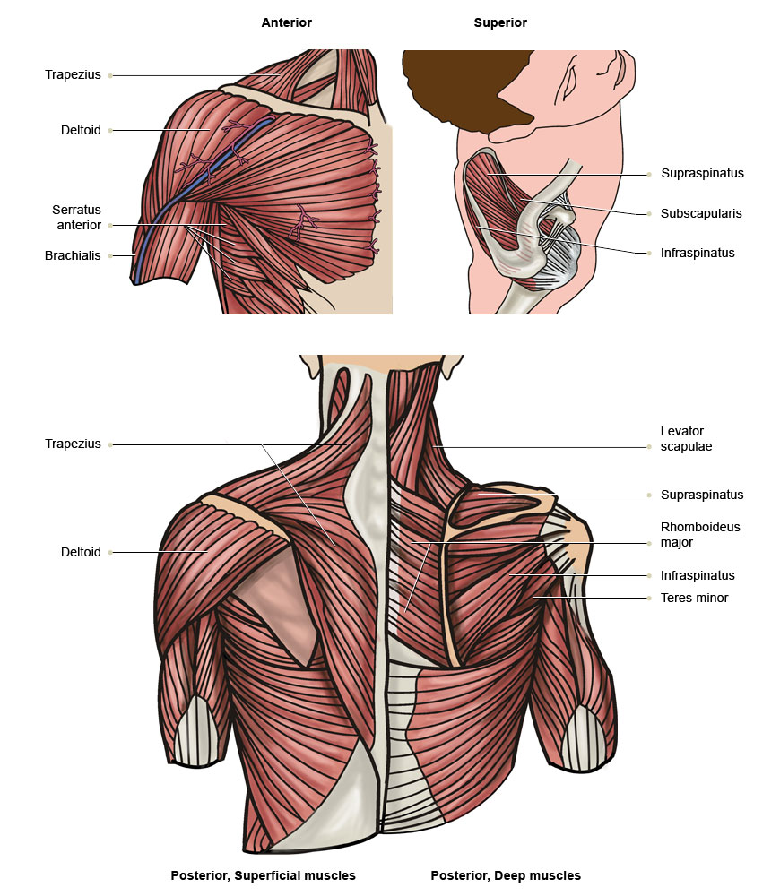

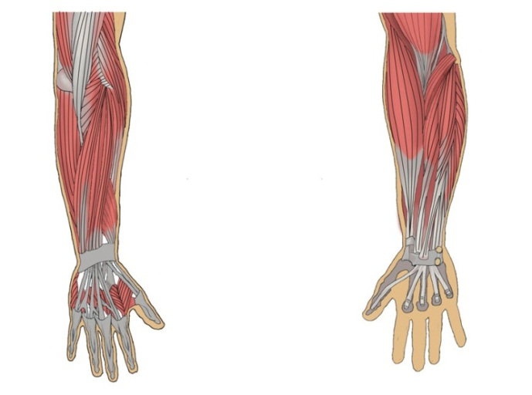

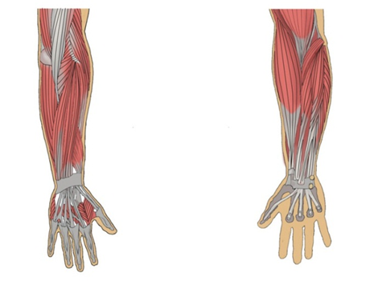

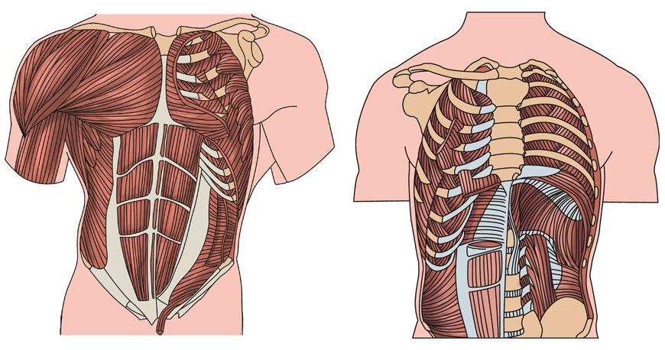

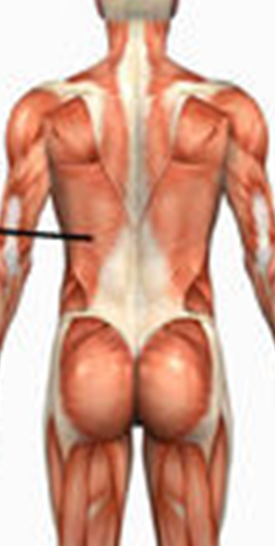

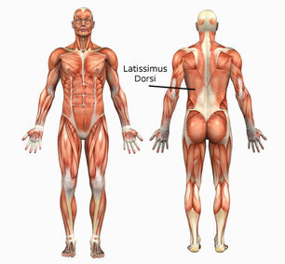

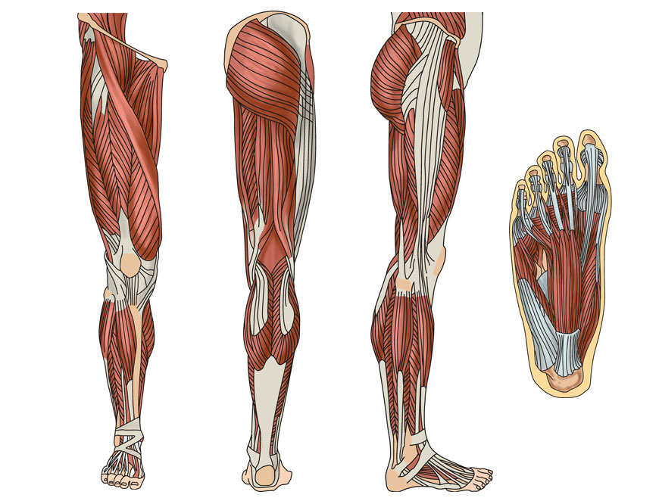



**iv) What are the functions of muscles?**

**c. Complete the table below with the position and action of the muscles:**

|  |  |  |
| --- | --- | --- |
| **Muscle** | **Position** | **Action** |
| Sterno Cleido Mastoid |  |  |
| Splenius Capitis |  |  |
| Splenius Cervicus |  |  |
| Rotator cuff muscles |  |  |
| Deltoid |  |  |
| Biceps |  |  |
| Triceps |  |  |
| Wrist Flexors |  |  |
| Wrist Extensors |  |  |
| Brachioradialis |  |  |
| Trapezius |  |  |
| Rhomboids |  |  |
| Latissimus Dorsi |  |  |
| Erector Spinae |  |  |
| Pectorals |  |  |
| Intercostals |  |  |
| Diaphragm |  |  |
| Rectus Abdominis |  |  |
| Obliques |  |  |
| Gluteals |  |  |
| Piriformis |  |  |
| Hamstrings |  |  |
| Quadriceps |  |  |
| Adductors of upper leg |  |  |
| Gastrocnemius |  |  |
| Soleus |  |  |
| Tibialis Anterior |  |  |
| Corrugator |  |  |
| Frontalis |  |  |
| Platysma |  |  |
| Orbicularis Oris |  |  |
| Mentalis |  |  |
| Masseter |  |  |
| Orbicularis Oculi |  |  |
| Buccinator |  |  |
| Zygomatic |  |  |

**d. i) Label the diagram of the skeleton:**

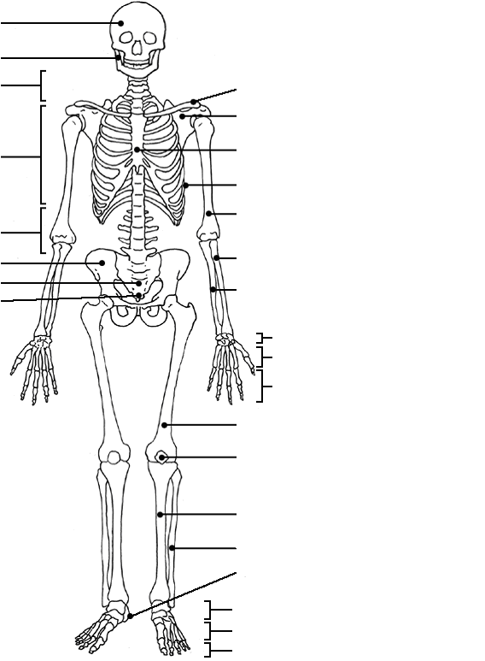

ii) What are the functions of the skeleton?

**iii) Name and describe the joint and type of movements for the following:**

|  |  |  |
| --- | --- | --- |
| **Joint** | **Joint type** | **Movement** |
| Knee |  |  |
| Hip |  |  |
| Elbow |  |  |
| Wrist |  |  |
| Foot |  |  |

1. **Briefly describe how you would recognise following types of postural and skeletal conditions :**

|  |  |
| --- | --- |
| **Condition** | **Description** |
| Lordosis |  |
| Scoliosis |  |
| Osteoporosis |  |
| Spondylitis |  |

1. **Explain the relationship between the blood and lymph within the circulatory system**
2. **Explain the interaction between blood and lymph in the circulatory system**
3. **Label the diagrams relating to the lymphatic system**

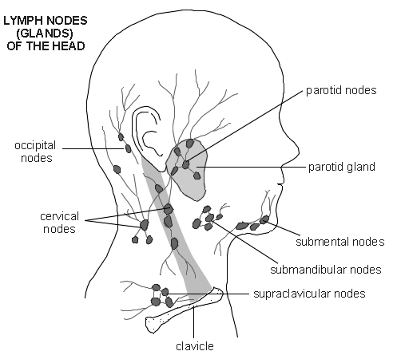

|  |  |
| --- | --- |
| Lymphatic System | Structure and Function |
| Lymph Vessels |  |
| Lymph Nodes |  |

**ii. Label the lymph nodes of the body**

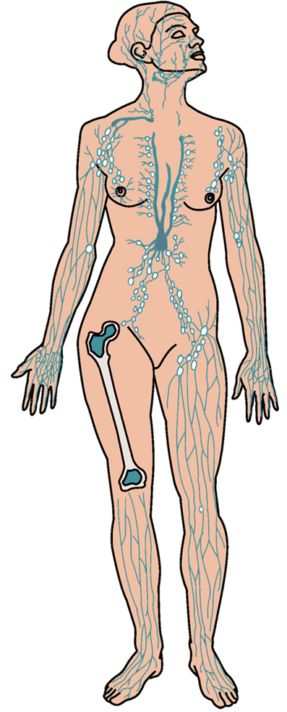

**i. Describe the principles of the nervous systems below:**

|  |  |
| --- | --- |
| Nervous System | Principles |
| Central Nervous System |  |
| Autonomic Nervous System |  |

**j. State the basic principles of the following systems**

|  |  |
| --- | --- |
| System | Principal |
| Endocrine |  |
| Respiratory |  |
| Digestive |  |
| Excretory |  |

1. **Label the diagram of the skin**

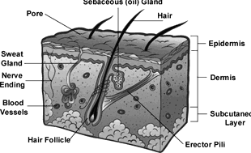

**ii) Name the layers of the epidermis & explain the function of each layer**

|  |  |
| --- | --- |
| Layer | Function |
| 1. |  |
| 2. |  |
| 3. |  |
| 4. |  |
| 5. |  |

1. **Name the skin characteristics and skin types of different ethnic client groups**

|  |  |
| --- | --- |
| Ethnic group | Skin types & skin characteristics |
| White |  |
| Black |  |
| Asian |  |
| Mixed |  |

1. **Complete the structure & location of adipose tissue.**

|  |  |
| --- | --- |
| Structure | Location |
|  |  |

1. **Name two effects that massage using pre-blended aromatherapy oils would have on the each of the following body systems:**

|  |  |
| --- | --- |
| System | Effects |
| Circulatory system |  |
|  |
| Muscular system |  |
|  |
| Nervous System |  |
|  |
| Digestive System |  |
|  |

1. **Briefly describe the physical and psychological effects of body massage on the client:**

|  |  |
| --- | --- |
| Physical | Psychological |
|  |  |

1. How would you recognise erythema and its causes?

# Knowledge – Outcome 9

Understand contra-indications and contra-actions that affect or restrict massages using pre-blended aromatherapy oils

A & b. Briefly describe each of the contra-indications and restrictive contra-indications listed below:

|  |  |
| --- | --- |
| **Contra/Restrictive contra-indication** | **Description** |
| **Deep vein thrombosis** |  |
| **Chemotherapy and radio therapy** |  |
| **Contagious skin diseases** |  |
| **Varicose veins** |  |
| **Epilepsy** |  |
| **Diabetes** |  |
| **Heart disease** |  |
| **High and low blood pressure** |  |
| **Skin disorders** |  |
| **Recent scar tissue** |  |
| **Recent fractures or sprains** |  |
| **Undiagnosed lumps and swelling** |  |
| **Product allergies** |  |
| **Certain medication** |  |

* 1. **List the contra-actions that may occur during and after treatment, and detail why they may occur, and how you would deal with them**

|  |  |  |
| --- | --- | --- |
| Contra-action | Reason for occurrence | Action taken |
|  |  |  |

# Knowledge – Outcome 10

**Understand how to use pre-blended aromatherapy oils**

1. **Detail how you would store and maintain pre-blended aromatherapy oils in a safe and hygienic way:**

|  |  |
| --- | --- |
| Store | Maintain |
|  |  |

1. How would you use pre-blended aromatherapy oils safely? Explain the effects of volatility

|  |  |
| --- | --- |
| Use of pre-blended oils | Volatility |
|  |  |

c. Briefly detail the pre-blended aromatherapy oils available and their use:

|  |  |
| --- | --- |
| **Pre-blended oils** | **Uses** |
|  |  |
|  |  |
|  |  |

* 1. How would you adapt your choice of pre-blended aromatherapy oil to meet the client’s physical needs?

**KNOWLEDGE – Outcome 11**

**Understand the principles behind massage techniques using pre-blended aromatherapy oils**

1. Why is it important to maintain correct posture during massage and complete your own stretching exercises to prevent repetitive strain injury:

i. To prevent strain and fatigue

ii. So that the therapist isn’t too close to the client

iii To stop the therapist’s uniform from getting oily

iv. So that a deeper pressure movement can be performed

1. Which massage techniques would be used to meet the following client objectives?

|  |  |
| --- | --- |
| **Objective** | **Massage techniques** |
| Relaxation |  |
| Sense of Wellbeing |  |
| Uplifting |  |
| Anti-cellulite |  |
| Stimulating |  |

c. How would you adapt the massage sequence, depth and pressure of massage to suit the following:

|  |  |
| --- | --- |
| **Physical characteristics** | Adaptation of sequence, depth and pressure |
| Weight |  |
| Height |  |
| Posture |  |
| Muscle tone |  |
| Age |  |
| Health |  |
| Skin condition |  |
| Areas of the body |  |
| Face |  |
| Head |  |
| Chest & Shoulders |  |
| Arms & Hands |  |
| Abdomen |  |
| Back |  |
| Gluteals |  |
| Legs & Feet |  |

d. What would be the adaptations to the massage treatment for male and female clients?

* 1. Explain which areas of the body, and body characteristics need particular care when using pre-blended aromatherapy oils

f. List the advantages of massage using pre-blended aromatherapy oils:

g. How and why would support and cushioning be used during the treatment?

1. What are the limitations of using pre-blended aromatherapy oils?

ii) When would you refer clients to a clinical aromatherapist, and why?

i. Why is it important to evaluate the effectiveness of body massage treatment?

# Knowledge – Outcome 12

Understand how to provide aftercare advice

1. What advice would you give the client on lifestyle factors and changes that may be required to improve the effectiveness of the treatment?
2. Explain post-treatment restrictions and future treatment needs

|  |  |
| --- | --- |
| Post treatment restrictions | Future treatment needs |
|  |  |

1. Detail the products for home use that will benefit the client, and those to avoid and why.

|  |  |
| --- | --- |
| Products for home use | Products to avoid & why |
|  |  |

d. Briefly describe the following:

|  |
| --- |
| How eating and exercise habits can affect the effectiveness of treatment |